MS.NET

Mini Project

Employee Travel Booking Application

(ETBA)

Document Revision History

|  |  |  |  |
| --- | --- | --- | --- |
| **Date** | **Revision No.** | **Author** | **Summary of Changes** |
| 22-May-2018 | 1.0 | Meganadha Reddy K | Initial Draft |
|  |  |  |  |
|  |  |  |  |
|  |  |  |  |
|  |  |  |  |

Table of Contents

Introduction 5

Setup Checklist 5

Instructions 5

Problem Statement 6

Objective 6

Abstract of the project 6

Functional components of the project 8

Technology used: 9

Implementation 10

Summary of the functionality to be built: 10

Guidelines on the functionality to be built: 10

Introduction

This document outlines a mini project for the .NET Line of Technology (LOT). The project is to develop Online Taxi Booking System. This document contains the requirements, work flow of the system and gives guidelines on how to build the functionality gradually in each of the course modules of the .NET LOT.

## Setup Checklist

Minimum System Requirements

* Intel Pentium 4 and above Windows 2007, 2008 and 2010
* Memory 4 GB
* Internet Explorer 8.0 or higher
* SQL Server 2012 client and access to SQL Server 2012 server
* Visual Studio 2015/2017

## Instructions

* The code modules in the mini project should follow all the coding standards.
* Create a directory by your name in drive **<drive>**. In this directory, create a subdirectory **MiniProject**. Store your Project here.
* You can refer to your course material.
* You may also look up the help provided in the MSDN
* Since this project work will span over couple of months, you will need to take care of maintaining the code

Problem Statement

## Objective

Development of Employee Travel Booking Application

**Abstract of the project**

**Employee Travel Booking Application** allows Employees to place requests for booking business travel tickets.

In current corporate world, Employees are often required to travel to Domestic as well as international locations based on business requirements. This application “Employee Travel Booking Application” will help employees to raise or submit a ticket for travelling to the required location.

Employee Travel Booking System is an online system which will automate the process of raising or placing a travel requests. Employees will raise or place the travel request. Manager can approve, reject the request. Once manager approves the request travel agent will confirm the travel or can make the status as Bookings not available.

The system will have 4 users / actors: Employee, Manager, Travel Agent, and Admin

**Role of Admin**

1. Add Employee, Assign manager
2. Change Manager, Delete Employee.
3. Add/Edit Travel Agents

**Role of Employee**

1. Check current requests submitted and see the status
2. Raise new travel request
3. Cancel the request made.

**Role of Manager**

1. Approve or Reject the travel request raised by Employee
2. Check the history of requests made by reporting employees.

**Role of “Travel Agent”**

1. Once Manager approves the travel request of employee, travel agent will change the status to “Ticket Confirmed” or “No Availability” status.

## high level – business flow diagram [illustration purpose only]

Employee raises a travel request

Manager

Approves

Travel request?

No

## 

Status “Rejected”

Status “Approved”

Travel agent finds tickets are available

Yes

## Functional components of the project

Status “Booking Not Available”

Status “Booking Confirmed”

No

Yes

**Application Architecture:**

Distributed web applications traditionally to be designed and built across three logical tiers:

* Database Access Layer (DAL)
* Business Logic Layer (BLL)
* Presentation Layer

The DAL refers to the database itself, the stored procedures, and the component that provides an interface to the database. The BLL refers to the component that encapsulates all the business logic of the application. And, the Presentation layer refers to the web application pages.

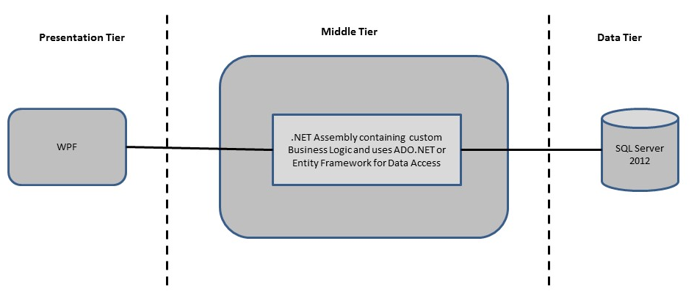

**Design guidelines**

* All the exceptions/errors to be captured and user friendly message to be displayed on the Common Error page.
* Data access layer of 3-tier useADO.NET data access using SQL stored procedures - All the database interaction would be performed using Data Access Component. Most common methods in Data Access Component would be –

1. Create Connection to the Database
2. Create Command Object
3. Set Command Type to Stored Procedure
4. Create and Populate Parameters
5. Execute the Command
6. Close the Connection

## Technology used:

* + - *Presentation Layer* 
      1. *WPF 4.5*
    - *Business Layer*
      1. *Business Logic Components and Services :-* 
         1. C# 5.0/6.0
    - *Database Layer*
      1. *Databases:-*
         1. SQL Server 2012+

Implementation

## Summary of the functionality to be built:

The participants need to develop the Online Taxi Booking System by building the functionality incrementally in each of the course modules of .NET LOT.

|  |  |
| --- | --- |
|  | |
| **Sr. No** | | **Course** | **Duration** | **Functionality to be built** |
| **(in PDs)** |
| 1 | | MS SQL Server 2012 / + | 4 | Creating relevant database tables and stored procedures |
| 2 | | NET Framework 4.5 + C# 5.0/6.0 | 7.5 | Developing Business components (C# classes) |
| 3 | | ADO.NET 4.5 | 3 | Integrating the DAL ,BLL and PL |
| 4 | | LINQ and Entity Framework | 2 | Creating data model and data context and using LINQ to entities |
| 5 | | WPF 4.5 | 2 | Incorporating advanced UI functionality with WPF 4.5 |
| 6 | | Mini Project Presentation | 1 | The Mini Project Presentation day |

# Note: Saturday half day will be devoted for mini project

## Guidelines on the functionality to be built:

The functionality and components to be built in each of the course modules of .NET LOT is as follows:

1. **Course: SQL Server 2012+**

This section describes some of the basic steps involved in designing and creation of the database for the application.

Create Data Model - identify the different tables and fields that we will need, which would later be used for building the rest of the application.

Database Schema - Taking these objects, we can easily identify our main tables in the database.

* 1. Create the following database tables with following fields: [make your assumptions in case you require few more fields]

|  |  |
| --- | --- |
| UserType | UserTypeId, Description |
| TravelRequests | RequestId, RequestDate, FromLocation,  ToLocation, UserId, CurrentStatus |
| Users | UserId, LoginId, Password  UserTypeId, Name, ManagerUserId |

1. **Course: WPF 4.5**
   1. Develop the prototypes for following functionalities:
      1. **Admin Screen**: Admin user should be able to add or edit Employees and assign respective managers. Also should be able to add Travel agents.
      2. **Employee screen**: Employees should be able to enter From Location, To Location and Travel data and click on ‘Submit’ button to raise a travel request.
      3. **Manager Screen**: Once employee successfully places travel request, Manager can approve or reject the same. Also, Manager can view the reports of total number of requests received and respective status.
      4. **Travel Agent Screen**: Once manager approves the request, based on availability travel agent can change the status to “Booking Confirmed” or “Booking Not available”.
2. **Course: C# 5.0/6.0 and ADO.NET 4.5**
   1. Develop business components (C# classes) for the following functionality:
      1. User Class :- This class will contain methods which will allow to manage all employee
      2. TravelRequest class :- This class will contain methods to manage customer
      3. UserType class :- This call will contain Types of users – Admin, Employee, Manager

You need to create Layered Architecture which comprises of Presentation Layer (winforms / WPF), Business Logic Layer (C# Classes) and DAL Layer (Using ADO.Net 4.5 / Linq and Entity Framework)

DAL Layer of ADO.NET 4.5 will include all the required code snippets for CRUD Operations.

All the CRUD operations should use SQL Server Stored Procedures (For Insert, Update, Delete and Search).

The connectionString should be stored in the configuration file only.

**OR**

1. **Course : LINQ and EF**
   1. Use the database first approach and create the Entity data model consist of the following entities :
      1. User Class :- This class will hold the basic details of all users
      2. UserType Class :- This class will hold the types of users.
      3. TravelRequests Class :- This class will hold the details of requests raised by employees
   2. Use Data context to perform CRUD operations and Implement the required logic using LINQ (like retrieving data, sorting data, searching data etc).
2. **Course: ADO.NET 4.5 and WPF 4.5**
   1. Integrate all screens (Winforms, WPF pages) with business components (C# classes) to complete the entire functionality

### Project Evaluation Guidelines

The project it is to be evaluated based on the following five parameters:

1. Proper Database Structure and UI designing as per the specifications –(15 Marks)
   1. Proper Database Design and Stored Procedure
   2. Visual look and feel of the UI
2. Project Completion – (20 Marks)
   1. Timely Completion of the project
   2. Integration of all component of the system
3. Defect free execution – (30 Marks)
   1. Error free execution of individual modules and the whole system
   2. Validation
   3. Functionality as per the specified requirements
4. Compliance of standard and guidelines – (15 Marks)
   1. Appropriate comments entries
   2. Adherence to naming conventions for classes, functions, variables and files
   3. Simplicity of user interface and screen layouts
   4. Maintainability of codes (for example, no one function should be more than 100 lines)
5. Group Presentation and Query handling – (20 Marks)
   1. Participants (Group of 3 to 4) to present the project with UML Diagrams(use case diagram and one of the sequence or activity diagram) and PPT